Chapter 12, Problem 20.

Using Fig. 12.51, design a problem to help other students better understand balanced delta-delta connected circuits.
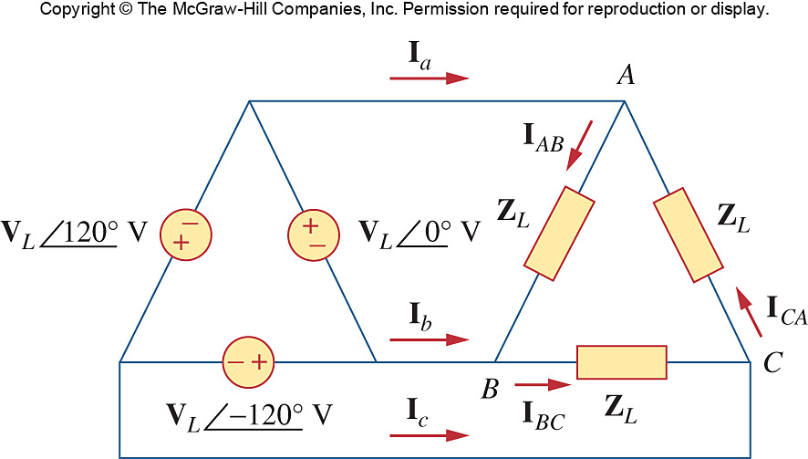

Figure 12.51
For Prob. 12.20.

